PhonePe Transaction Insights

Documented By: Gowtham

Overview
With the rise of digital payments in India, platforms like PhonePe play a major role in transforming financial behaviour.
This project aims to explore, analyse, and visualize aggregated transaction data from PhonePe Pulse to uncover meaningful insights about user engagement, service adoption, and regional trends.

Project Objectives
- Analyse UPI transaction trends using PhonePe Pulse data

- Visualize transaction values across states, districts, and pin codes

- Identify top-performing locations and most-used service categories

- Build an interactive dashboard to explore data dynamically

- Support strategic decision-making for stakeholders through insights

Dataset Details
- Source:
  - The data pulled from Phonepe pluse git repository
- Format:
  - JSON files containing quarterly aggregated data year and state wise
- Categories:
We have three kinds of transactions in our JSON data
    - Transactions
    - User engagement
    - Insurance
- Insights: State, district, and pin code levels

Technology Used
- Language: Python
- Libraries:
  - Data Processing: Pandas, NumPy
  - Visualization: Plotly, Matplotlib
  - Mapping: GeoPandas, Plotly Choropleth
- Frontend: Streamlit

ETL Process Flow
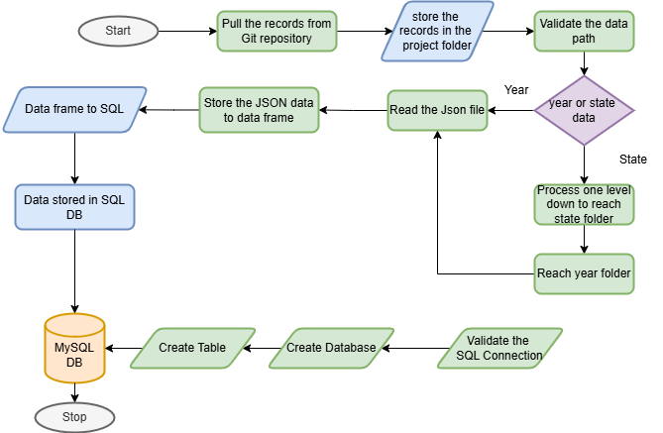

Features & Visualizations
- Year-wise and quarter-wise transaction trend analysis
- State and district-level choropleth maps
- Pie and bar charts for category-wise usage
- Line graphs for temporal analysis
- Interactive filters: Year, State, Quarter
Key Insights
- Digital transactions have increased significantly since 2018
- Maharashtra, Karnataka, and Uttar Pradesh are top-performing states
- Mobile recharges and P2P transfers are the most used services
- District and pin code analysis highlights micro-trends
- Smaller towns show rising adoption post-pandemic

Conclusion
This project provides a comprehensive view of UPI transaction behaviour in India using PhonePe Pulse data. It enables users to explore trends interactively and supports data-driven decision-making for fintech businesses, marketers, and policy planners.

